Chat away
Software Design Template
Version 1.0

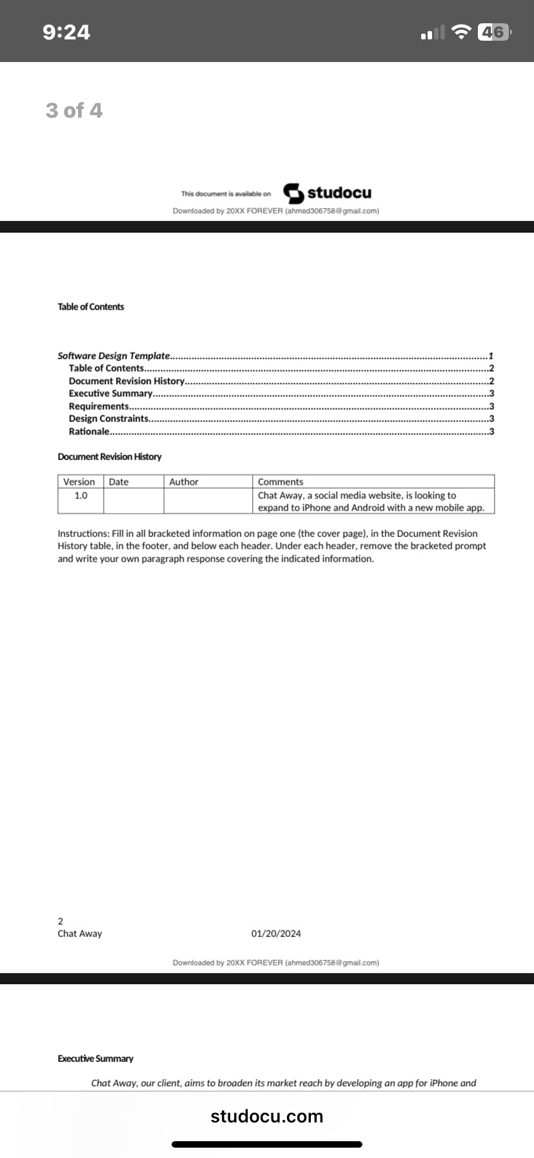

09/14/25. Ahmed Ahmed

Executive Summary
<The goal of Chat Away, a prosperous social media business, is to create a mobile application in order to broaden their customer base and boost sales. They want that the software be accessible on both the Android and iPhone operating systems. To keep costs down, the corporation wants to outsource this project.>
Requirements
<Business Requirements:
The mobile app must be available on both iPhone (iOS) and Android platforms to maximize market reach.
The app should be developed within a limited budget as the project is outsourced to stay cost-effective.
Technical Requirements:
The app must be compatible with the latest versions of both iOS and Android operating systems.
It must include features that are standard for social media applications, such as user profiles, messaging, notifications, and media sharing.>
The app should integrate seamlessly with the existing Chat Away website and backend systems.

Design constraints
<Cross-Platform Development:
Constraint: The need to develop the app for both iOS and Android platforms.
Rationale: This requirement can be addressed by using cross-platform development frameworks like
React Native or Flutter. These tools allow for a single codebase to be deployed on both platforms,
reducing development time and cost.
Budget Constraints:
Constraint: The project must be completed within a tight budget.
Rationale: Outsourcing the project and using cross-platform frameworks can help manage costs. Additionally, leveraging open-source libraries and tools can reduce licensing fees and development
expenses.
Integration with Existing Systems:
Constraint: The app must integrate with the existing website and backend.
Rationale: Ensuring compatibility with existing APIs and data structures is crucial. This may require thorough documentation of current systems and possibly adapting the backend to support mobile app functionalities.>
Rational
<According to the client, they wish to make the app available on both Android and iPhone. We must create a functional application that complies with the limitations of both operating systems because Android and Apple employ distinct operating systems. This implies that the program must adhere to the stringent rules established by both app marketplaces. Additionally, according to the client, the business is outsourcing in order to stay inside a predetermined budget. The app should probably keep the essential features of the currently popular web application.>

